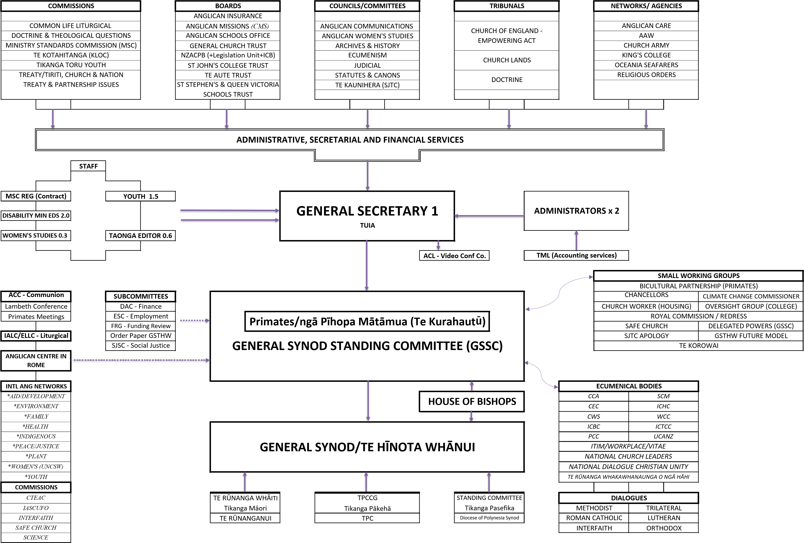
https://synod365-my.sharepoint.com/personal/m_alix_anglicanchurch_org_nz/Documents/Documents/As at 13Mar24 Updated Organisational Chart

GSTHW – General Synod/Te Hīnota Whānui (Title B/ Canon I/ Clauses 1 and 2 – ie B/I/1-2) Organisational Chart Key 2024 (updated March 2024)

Commissions
CLLC – Common Life Liturgical Commission (B/XXX)
CDTQ – Commission on Doctrine and Theological Questions (B/ XVII)
MSC – Ministry Standards Commission (D/II)
TeK – Te Kotahitanga (A Standing Commission for oversight of theological education, ministry training and formation, and other education and training relevant to advancing the mission and ministry of the church). Governors of SJTC – St John’s Theological College, (E/II/3), and have a sub-committee KLOC – The Kinder Library Oversight Committee. (E/II/3.12.8)
TTYC – Tikanga Toru Youth Commission (B/XXXVI)
Commission on Treaty & Partnership Issues (only convened by GSSC when required to consider matters related to the Treaty of Waitangi and the three Tikanga partnership) (B/XXXI)
Treaty/ Tiriti, Church and Nation Commission (strengthens the Treaty of Waitangi / Tiriti o Waitangi in the life of the Church and in Aotearoa New Zealand as a whole, and the Three Tikanga character of this Church) (B/XXXIII)

Boards
AIB – Anglican Insurance Board (B/XXXII)
AMB – Anglican Missions Board (B/IX)
ASO – Anglican Schools Office Board (SR Standing Resolution - A7)
GCTB – General Church Trust Board (F/V)
NZACPB – New Zealand Anglican Church Pension Board (incorporates the ALU – Anglican Legislative Unit) (B/XIV)
SJCTB – St Johns College Trust Board (E/II/4)
TATB – Te Aute Trust Board (SRA6 and A6b)
SSQVSTB – St Stephens and Queen Victoria Schools Trust Board (SRA5 and A6)

Councils/Committees
ACMO – Anglican Communications and Media Office (B/XIX)
CAWS – Council for Anglican Womens Studies (B/XXXV)
Archives and History Committee / Te Puna Nehera (B/X)
CFE - Council for Ecumenism (B/XVIII)
JC – Judicial Committee (C/IV)
Statutes and Canons Committee (C/III/6 and SO 83.2 and 3)
Te Kaunihera (St John’s College Governors) (E/II)

Tribunals
Church of England Empowering Act 1928 Tribunal (considers appeals regarding a departure from the Doctrine and Sacraments of Christ as defined in clause one of the Constitution) (1928 Act/4e and 5)
Church Lands Tribunal (can establish if land which is Trust property has been acquired from Maori for a purpose narrower or more restrictive than the trust imposed on that land by Crown Grant or otherwise when the land was vested in the Church or any person on behalf of the Church) (F/VII)
Doctrine Tribunal (decides all questions of Doctrine referred to it by a group of at least seven people, one of whom must be a Bishop, one a priest or deacon, and one a lay person) (C/V)

TUIA – General Synod Office
GenSec - General Secretary (B/I/5) – with Administrators (2 FTE) provides administrative, secretarial and financial services to much of the above and below.
GSTHW Staff – Women’s Studies Administrator (part-time), Youth Commissioner and part-time Projects Manager, Taonga Editor (Magazine and Online – part-time), Disability Ministry Educators (2 half time), MSC Registrar (contracted part time).

GSSC – General Synod Standing Committee (B/I/3)
Chaired by the three Archbishops (The Primacy), plus one member from each Hui Amorangi and each Pākehā Diocese, plus three from Pasefika, plus one youth/Rangatahi from each Tikanga.
Sub Committees (permanent)
- DAC – Distribution Advisory Committee (Finance, and advises GSSC and GCTB on the annual distribution and the GSTHW budgets) (B/I/4.4 and 4.5)
- ESC – Employment Sub-Committee (advises GSSC and deals with GSTHW staff above) (B/I/3.11)
- FRG – Funding Review Group (advises GSSC on annual SJCTB common-life funding applications)
- OPC - Order Paper Committee (manages the GSTHW agenda and arrangements) (SO11)
- SJSC – Social Justice Sub- Committee (manages the Social Justice Unit)
SWG – Small Working Groups (established for a set time/ project)
- Royal Commission/Redress (includes the legal team for the RC and developing a redress system)
- Climate Change Commissioner (developing a proposal for a Commissioner, from GSTHW 2018)
- Chancellors/Legal Advisors SWG (meets as required to advise on canonical/legal matters)
- Church Worker housing (researching housing needs, reporting to GSTHW 2022)
- Oversight of Implementation Group (for college review recommendations in 2021)
- Bicultural Partnership (established by GSTHW 2016 to enact Motion 23)
- Te Korowai
- Safe Church
- Delegated Powers (GSSC)
- SJTC Apology
- GSTHW Future

Ecumenical Bodies and Dialogues
Anglican-Methodist Dialogue
ARCCANZ - Anglican Roman Catholic Churches of Aotearoa New Zealand Dialogue
CCA – Christian Conference of Asia
CEC - Churches Education Commission (Launchpad)
CWS - Christian World Service
ICBC – Interchurch Bioethics Council
ICHC – Interchurch Council for Hospital Chaplaincy
ICTCC – Inter-Church Tertiary Chaplaincy Council
Interfaith Dialogue
ITIM/ Vitae/ Workplace Support – Inter-Church Trade and Industrial Mission
Lutheran
NCLANZ - National Church Leaders of Aotearoa New Zealand
National Dialogue for Christian Unity in Aotearoa New Zealand Orthodox
PCC – Pacific Conference of Churches (via Diocese of Polynesia)
SCM – Student Christian Movement
Trilateral
UCANZ – Uniting Congregations of Aotearoa New Zealand
WCC – World Council of Churches

International
ACC – Anglican Consultative Council
Lambeth Conference of Bishops (Each 10 Years)
Primates Meetings
Anglican Centre in Rome
IALC – International Anglican Liturgical Consultation
ELLC – English Language Liturgical Consultation

International Anglican Networks
AARDA – (or AA) Anglican Alliance for Relief, Development and Aid
ACEN – Anglican Communion Environmental Network
ACYN - Anglican Communion Youth Network
AHN – Anglican Health & Community Network
AIN – Anglican Indigenous Network
APJN – Anglican Peace and Justice Network
Commissions –
Interfaith
Inter Anglican Standing Commission on Unity, Faith & Order (IASCUFO)
Safe Church
Science
Theological Education (CTEAC)
IAFN – International Anglican Family Network
IAWN – International Anglican Womens Network (also meets annually at UNCSW – United Nations Consultation on the Status of Women)
Plant Anglican – Anglican Communion Church Planting Network

